4" PTS Set-Up Instructions

- Put your pole together by pushing the two snap buttons in and slide the top portion of your pole up to the last set of holes near the top of your pole.

- Next, take the bottom portion of your pole and fit them into the middle and upper portion by lining them up, pushing in the snap buttons, and sliding them up until they lock into the first set of holes.

- Once together, repeat the process for the second pole.

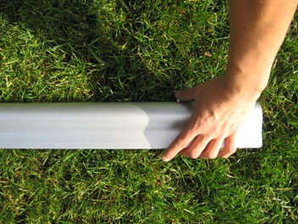

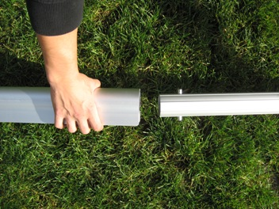

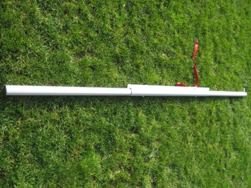

- For easy net set up, take the top cable and find the side with the pre-made loop. (If you have Kevlar or a Rope cable, just make a loop knot) Make sure that the cable only comes out about a foot or so and using the provided carabineer, clip it onto the eyebolt on the top of one of your poles.

- Now take the top cable on the opposite side and about a foot away from the vinyl of your net make a loop with the provided cable clamps. (If you have Kevlar or a Rope cable, just make a loop knot)

- Once you’ve made your loop, connect it to the eyebolt at the top of your pole using the provided carabineer clip.

- Now find your red webbing guy wires and attach the first guy wire to the top of your pole. You want to take the short strap, connected to the buckle, and loop it over the top of your pole. Make sure you loop the correct end that is fixed onto the buckle and does not move through the buckle.

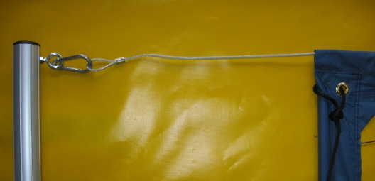

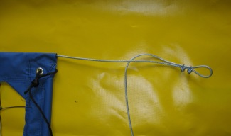

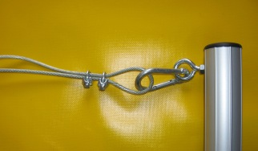

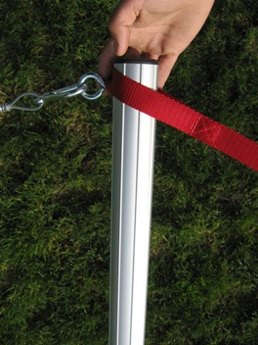

- Stretch your net and poles out laying them on the ground. (lower left image)

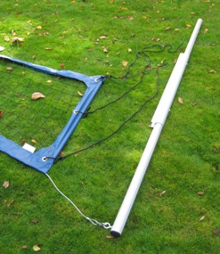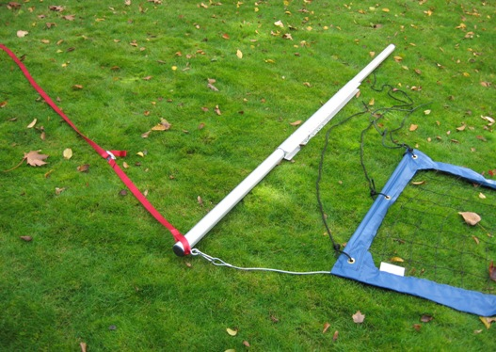

- Starting with the first pole, take your first guy wire and pull it away from your court at a 45-degree angle (upper right image). Then take a stake, slide it through the metal d ring on the guy wire, and pound it into the ground until nail head is below ground level. Stand your pole up, put another guy wire around the top of the pole, and angle it in the opposite direction of the first guy wire (45-degrees in the other direction) and then pull a third straight back away from your court to finish (image at the right hand corner of the page).

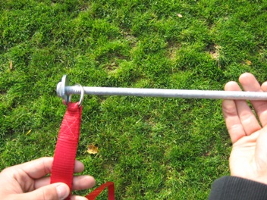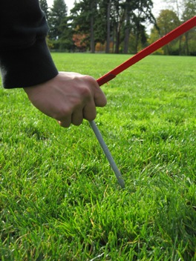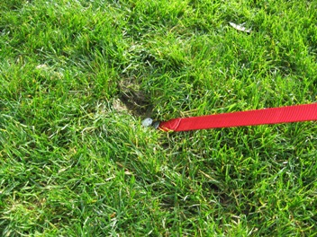

- All three guy wires should hold the pole in place while you assemble the opposite side. Your pole should be angled in towards your court about 20 degrees (image below).

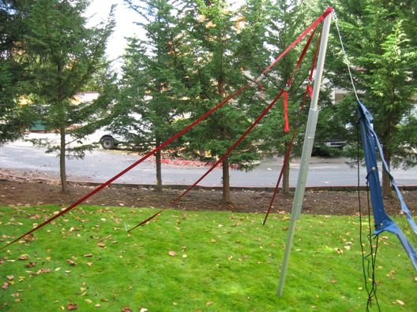

- Repeat the process for the other pole. Some adjusting may be required by moving the guy wires around to get your pole in the right position. Then one by one pull the loose ends of your guy wire straps to tension your pole until it stands straight up and down. Straighten your pole once tension is applied, if it isn’t straight up and down. Do this by lifting the pole while under full tension just enough to slide it along the ground and into place.

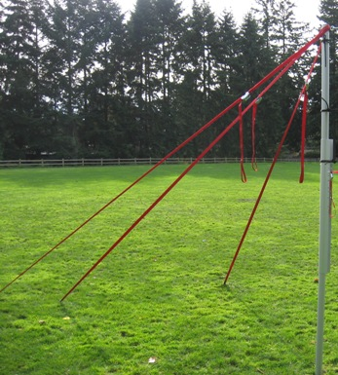

- Once you have good tension on the top of your net, tighten the bottom. Start on the pole which has the bolt running through it (not the red cam buckle tension strap attached to it). Take the cable and make a loop (if you have a pre-made loop on the bottom cable, use this here) about 1 foot away from the vinyl of your net and connect it to that bolt by using the provided carabineer clip.

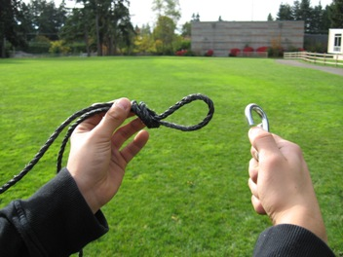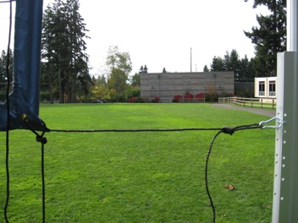

Now, make a loop on the other side of your net where you’ll be attaching it to the red cam buckle tension strap on the pole. Make a loop right as the cable comes out of the net and use the as much of the tension strap as you can to connect the cable to the pole.

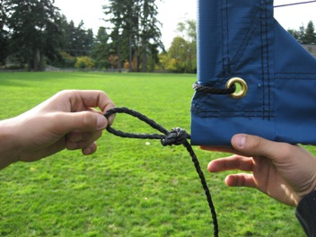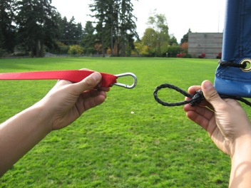

- To center your net on your court, stretch the vinyl, and to add extra tension, tie the black rope on the side of your net around your pole and back to itself. (These ropes are optional and you can remove them if you are not using them.)

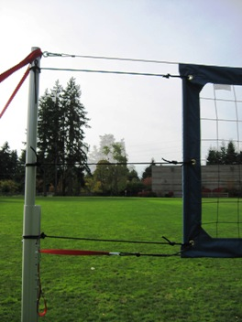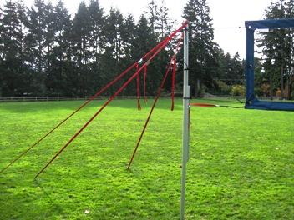

- Lastly, wrap your pole pads around your poles with the logo at the top. The pad should wrap around the back of your pole and connect to itself on the inside of your pole/on the court side.

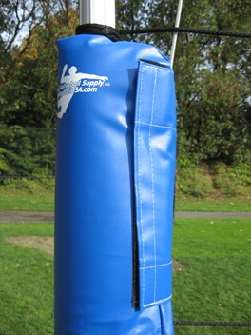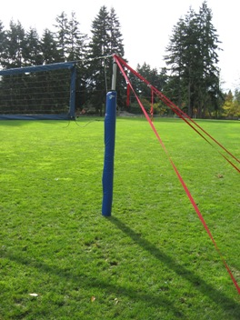
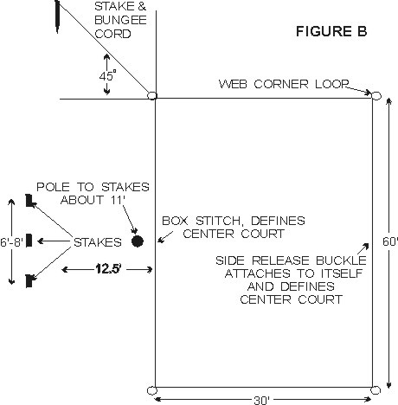
COURT LAYOUT
An ideal spot would be a flat grassy or sandy area free of holes or foreign objects with no limbs or wires overhead. Lay out web lines on the ground to form a rectangle, attach center court, side release buckles on one side of boundary. Other side of center court is marked by a box stitch, use tape if you prefer a larger mark. Attach hooks on bungee cord to each of the four large corner loops of the rectangle. Drive stakes into the ground at a 45-degree angle to the corner loop, or in sand bury them down about a foot at each corner. Do not pull too hard on bungee cord, just enough to get a straight line. Bungee cord will then stretch and snap back into place. Webbing stretches depending on how hard it is pulled on, so the size of your court can very. For set up on dry sand, you may need our #1026 sand kit.
CAUTION: WHEN REMOVING STAKES FROM THE GROUND ALWAYS GRAB BUNGEE CORD UP CLOSE TO STAKE AND PULL STRAIGHT UP OR DIG OUT OF SAND. ALWAYS USE BUNGEE CORD ATTACHED TO STAKE, TO ANCHOR CORNERS. DO NOT ANCHOR THE CORNERS WITH JUST A STAKE ALONE. USE PLASTIC ROLL UP RACK FOR BOUNDARY STORAGE. THE SUN WILL DETERIORATE THE WEBBING, DO NOT LEAVE OUTSIDE UNLESS IN USE AND NEVER LEAVE OUTSIDE OVERNIGHT, IT CAN BE A POTENTIAL HAZARD. WEBBING LINES ON THE GROUND MAY BE TRIPPED OVER, ALWAYS KEEP SMALL CHILDREN AWAY FROM PLAYING AREA, AND INFORM ALL OTHERS OF POTENTIAL HAZARD.

